רונן גליאדוב209506767

Talia BarZohar

Nir hazan

Miriam globtzki

דוד זף 207875147

**Music Project**

**Background music for gameplay and for main menu:**

the background music for the main menu and the gameplay were made in the following way:

The Music has 3 components: melody, accompaniment, and drums.

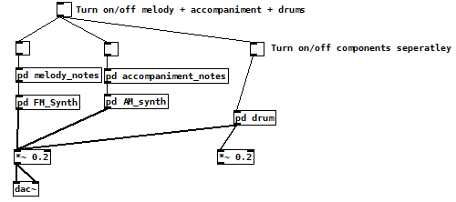

For the melody and accompaniment notes we used a sequencer, we designed the notes of the melody to synchronize with the notes of the accompaniment by adjusting each respective notes and metro.

Melody sequencer:

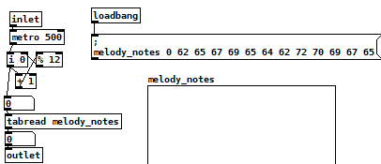

Accompaniment sequencer:

For the melody we used FM synthesis techniques by combining the main audio with overtones we also added to the noise a basic envelope to make the sound more colorful.

Fm synth:

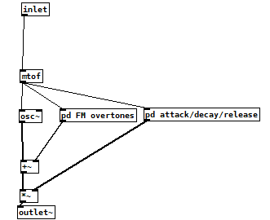

Fm overtones:

Each overtone was given a unique frequency and amplitude:

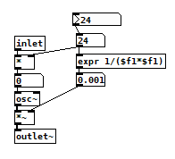

The accompaniment is very similar to the melody in terms of its structure only instead of using FM synthesis we used AM synthesis.

TODO: EXPLAINS DRUMS

**KILL sound effect:**

**LAZER sound effect:**

**RETRY /PLAY sound effect:**

**KILL sound effect:**